[1]

Asra Yousuf

School of Computing Science

and Engineering

VIT University, Vellore - 632014

Tamil Nadu, India

asrayousuf28@gmail.com

Venkatesan M

School of Computing Science

and Engineering

VIT University, Vellore - 632014

Tamil Nadu, India

[mvenkatesan@vit.ac.in](mailto:mvenkatesan@vit.ac.in)

Ipsita Prakash

School of Computing Science

and Engineering

VIT University, Vellore - 632014

Tamil Nadu, India

ipsita16@hotmail.com

Refinements for Rough Fuzzy C-means Clustering

*Abstract*— **The objective of the paper is to propose few refinements at different stages in the hybrid rough-fuzzy unsupervised clustering algorithm and determine its accuracy in forming clusters for a given set of data points. Specifically, it analyses and proposes a relative comparison of membership function, instead of an absolute relative, as basis for categorizing a point into the lower or the upper approximation of a cluster in order to to improve its structure’s accuracy. Moreover, it counters the generation of the inefficient hollow cluster generation in case of closely packed data points by assigning at least one data point to the lower approximation of each cluster. Several synthesized datasets are used to simulate different types of data pools and a quantitative comparison between raw and the refined hybrid algorithm is drawn using indices engaged in evaluating rough set and the deviations between the expected and generated centroids. The results are further corroborated using real data sets.**

Keywords — Clustering methods, clustering algorithms, fuzzy sets, fuzzy membership, rough sets, refined clustering, iris data, soft computing, pattern recognition, soft computing**.**

**1. Introduction**

Cluster is a term broadly used to describe a set of entities that resemble each other more closely than the entities in another cluster. This similarity is based on the degree of co-relation between a fixed set of pre-defined features that define these entities completely or partially. In soft computing clusters are generally represented by either fuzzy sets [1] or rough sets [2]. In case of fuzzy sets, members of a cluster are assigned membership values which lie in the interval [0,1] and signify the degree of belongingness of the entities to the specified set. On the other hand, rough sets model each cluster to enclose two regions: the lower approximation and the upper approximation. While entities in the lower approximation of a cluster belong exclusively to that cluster, entities that belong to the upper approximation but not the lower approximation are shared by more than one cluster.

Clustering is labelled as an unsupervised learning problem aimed at finding a structure in a scattered data-set. It is the process through which specific data points can be grouped together such that points within a group are similar to one another as compared to points belonging to other groups. The aim of clustering involves intrinsic grouping of unlabeled data and detect outliers in the data set.

A number of clustering algorithms have been proposed to classify data [3,4,5]. The most widely used and simple clustering algorithm is hard c-means [6] which assigns objects exclusively to one cluster. Clustering algorithms like Rough C-Means (RCM) and Fuzzy C-Means (FCM) harness cluster models of rough sets and fuzzy sets to represent partitions in a data set that share objects amongst those partitions. FCM, as proposed by Bezdek [7], quantifies belongingness of each data point to each cluster in the given data universe by assigning membership values for every such combination. While FCM is a useful clustering method it produces in accurate results in case of noise and outliers. To address this defect, Krishnapuram and Keller [8,9] proposed a possiblistic approach to calculate the membership value in order to represent the degree of belongingness. However, this possibilistic clustering algorithms forms coincident clusters for certain data distributions [10]. Rough cluster algorithms as introduced by Lingras et al. [11], do Prado et al. [12] and Voges et al. [13] assigns objects to lower approximation of a cluster if and only if the object belongs exclusively to that cluster. In case the object cannot be definitely categorized into a specific cluster, it is shared between the boundaries of two clusters. A hybrid clustering algorithm [14] combines RCM and FCM to design clusters in such a way that members in both the lower and the boundary of the cluster are assigned membership values. This algorithm borrows the efficiency offered by membership function in FCM while handling overlapping partitions and combines it with the ability of RCM to handle uncertainty, vagueness and incompleteness in data [15] to give more accurate results.

Clustering has applications in diverse fields ranging from web mining to text mining to marketing to medical diagnosis to natural disaster analysis. Transactional data of customers in a super-market or an e-commerce portal can be leveraged to understand similar customer behavior and characteristics in order to do targeted marketing [11]. Clustering can also be used in diagnosing cancer by providing the ability to group together lymph node tissue section which had been diagnosed with metastatic infiltration (cancer spread from its original location) [16]. Clustering algorithm is the backbone behind the search engine as it is used to group similar objects in one cluster. It provides result for the searched data according to the nearest similar object which are clustered around the data to be searched [17]. Clustering also finds applications in the field of climatology wherein it is used to define eco-regions via multivariate clustering [18].

similar customer behavior and characteristics to classifications of plants and animals in Biology to natural disaster analysis.

This paper aims at analyzing and addressing the possible shortcomings in the hybrid rough fuzzy c-means algorithm, similar to the analysis conducted by G. Peters [20]. It describes alternative mechanisms to remedy these issues and formulates a refined hybrid algorithm. To demonstrate the effectiveness of this new algorithm it is applied to synthetic data that simulates symmetric and noisy data distribution and the Davis Bouldin index [19] of this algorithm is compared with other algorithms. Furthermore, we apply the raw and refined hybrid rough fuzzy clustering algorithms to investigate their effectiveness by comparing the total number of objects in the clusters’ boundaries.

In this research, we have used certain standard notations and acronyms outlined as follows:

n number of objects;

c number of clusters;

µij membershipvalue of object i with respect to cluster-j;

$\underline{A}(β_{i})$ lower approximation of $β_{i}$;

$\overline{A}\left(β_{i}\right)$ upper approximation of $β_{i}$;

*w*, *w̃* weight of lower and upper approximation;

vi mean centroid of ith cluster;

φ Empty set;

ε Threshold value for iteration

δ Threshold value for rough set cluster allocation by linear difference

τ Threshold value for rough set cluster allocation by relative strength

*m* fuzzifier;

RCM Rough C-means;

FCM Fuzzy C-means;

RFCM Rough-Fuzzy C-means;

DB Davies-Bouldin index;

## C-Means Clustering

The c-means algorithm takes the input parameter, *c*, and partitions a set of *n* objects into *c* clusters so that the resulting intra cluster similarity is high but the inter cluster similarity is low. Cluster similarity is measured in terms of the *mean* value of the objects in a cluster, which can be viewed as the cluster’s *centroid* or *center of gravity*.

The c-means algorithm randomly selects *k* number of objects, each of which initially represents a cluster mean or center. For each of the remaining objects, an object is assigned to the cluster to which it is the most similar, based on the distance between the object and the cluster mean. The new mean for each cluster is then recomputed. This process iterates until the criterion function converges.

## Rough C-Means Clustering

Rough c-means algorithm as introduced by Lingras [11], describes a cluster by its centroid and its lower and upper approximations. In terms of rough set theory, the set of objects definitely part of a vague concept is said to belong to lower approximation whereas the upper approximation is the set of objects possibly belonging to the same. In rough c-means, an object can belong completely in one cluster or can be in the uncertainty region or boundary of two clusters. The lower and upper approximations are weighted differently. In each iteration step of the algorithm, the distance of objects from the cluster centroids are computed and if the difference between the two lowest distances is less than a specified threshold value the element is placed in the boundary of the two clusters. Otherwise, the element is placed in the cluster for which the distance is the minimum.

In rough clustering, all the properties of the rough sets are not considered. However, the family of upper and lower approximations is required to follow some of the basic rough set properties such as:

* An object *xj*can be part of at most one lower approximation. This implies that any two lower approximations do not overlap.
* An object *v* that is member of a lower approximation of a set is also part of its upper approximation (𝑥𝑗 ∈ BU𝑖 →𝑥𝑗 ∈ B̄𝑈𝑖). This implies that a lower approximation of a set is a subset of its corresponding upper approximation i.e. BU𝑖 ⊆ B̄𝑈𝑖
* If an object 𝑥𝑗is not part of any lower approximation, it belongs to two or more upper approximations. This implies that an object cannot belong to only a single boundary region.

## Fuzzy C-Means Clustering

Developed by Bezdek [7], the fuzzy C-means algorithm is a powerful method to classify fuzzy data by using the concept of objective function. It works on the concept of fuzzy-set theory and introduces a membership value for each data point thereby enabling overlapping clusters. Thus, in fuzzy c-means data may belong to one or more than one clusters. Each object will have a membership in every cluster; which represents the degree to which the element belongs to the cluster resulting in clusters which are not disjoint.

Let X = {𝑥1, 𝑥2, … , 𝑥𝑁 }, where 𝑥𝑗 represents the data objects. The objective of FCM algorithm is to minimize the Fuzzy C-means cost function given as in (1).

 (1)

V = {𝑣1, 𝑣2, … , 𝑣C}, where 𝑣i represents the cluster centers. The exponent 𝑚 ∈ [1, ∞] is the weighting exponent which determines the fuzziness of a cluster and µij ∈ [0, 1] refers to the membership of the object i with respect to cluster j.

## Rough Fuzzy C- Means Clustering

The Rough Fuzzy C-Means (RFCM) algorithm [14] combines the concepts of rough set theory and fuzzy set theory. The rough membership function is proved to be more general than the fuzzy membership function but has its drawback when it comes to the calculation of the membership values for union and intersection of rough sets. However, in fuzzy set theory we have definite formulae for the computation of the membership values. Thus the hybrid algorithm of rough and fuzzy C-means takes care of both the features by providing membership values to elements as well as modeling vagueness in data through the boundary concept. The concepts of lower and upper approximations in rough set deals with uncertainty and, vagueness whereas the concept of membership function in fuzzy set helps in enhancing and evaluating overlapping clusters.

According to rough set theory, if 𝑥𝑗 ∈ 𝐵𝑈𝑖 then object 𝑥𝑗 is contained completely in cluster 𝑈𝑖 and if 𝑥𝑗 ∈ B̄𝑈𝑖 then object 𝑥𝑗 belongs to cluster 𝑈𝑖 and also belongs to another cluster. Hence according to fuzzy set theory the objects in boundary approximation should have different degree of membership on the clusters. So in RFCM the membership values of objects in lower approximation are 𝜇𝑖𝑗 = 1 while for those in boundary region are determined by the membership values.

## Clustering Performance Indexes

The clustering algorithms described are partitive, requiring pre-specification of the number of clusters. The results are dependent on the choice of *c*. There exist validity indexes to evaluate the goodness of clustering, corresponding to a given value of *c*. In this paper, we compute the Davies-Bouldin (DB) index [19] to determine the cluster validity and for analyzing the performance of the clustering algorithms. The DB index is a function of the ratio of the sum of within-cluster distance to between-cluster separation. Let *{****x****1, . . . ,* ***x****|ck|}* be a set of patterns lying in a cluster *Uk*. Then, the average distance between objects within the cluster *Uk* is expressed as:



where **x***i*, **x***i’ ∈ Uk*, and *i !*= *i’*. The between-cluster separation is defined as:



where *xi ∈ Uk*, *xj ∈ Ul*, such that *k* = *l*. The optimal clustering, for *c* = *c*0, minimizes

 (2)

for 1 *≤ i*, *j ≤ c*. Thereby, the within-cluster distance *S*(*Ui*) is minimized while the between-cluster separation *d*(*Ui, Uj*) gets maximized. Like DB, the *D* is designed to identify sets of clusters that are compact and separated. Here, we maximize for 1 *≤ i*, *j ≤ c*. The inter-cluster separation is maximized, while minimizing intra-cluster distances. Note that the denominator of DB is analogous to the numerator of *D*.



**2. Clustering Algorithms**

## C-means Clustering

Input:

c: the number of clusters,

*D*: a data set containing *n* objects.

Output: A set of cclusters.

Method:

1. Arbitrarily choose *c* objects from *D* as the initial cluster centers;

2. Repeat

3. (Re) assign each object to the cluster to which the object is the most similar,

based on the mean value of the objects in the cluster;

4. Update the cluster means, i.e., calculate the mean value of the objects for

each cluster;

5. Until no change

## Rough C-Means

All the objects in lower approximation take the same weight *w* while all the objects in boundary take another weighting index (*w̃* = 1 − *w*) uniformly. Calculation of the centroid is modified to include the effects of lower as well as upper bounds.

Let $\underline{ A}\left(β_{i}\right)$ and $\overline{A}\left(β_{i}\right)$ be the lower and upper approximations of cluster βi, and B(βi) = { } denote the boundary region of cluster βi. The modified centroid calculation for rough c-means is given by:

$v_{i} =\left\{\begin{aligned}w×A+ \tilde{w}×B if\underline{ A}\left(β_{i}\right)≠ϕ, B(β_{i} ≠ϕ) \\ A if \underline{ A}\left(β_{i}\right)≠ϕ, B(β_{i}=ϕ) \\ B if \underline{ A}\left(β_{i}\right)=ϕ, B(β_{i}≠ϕ) \end{aligned}\right.$ (3)

$A=\frac{1}{|\underline{A}(β_{i})|}\sum_{x_{j}ϵ\underline{A}(β_{i})}{x_{j}}$; $B=\frac{1}{|B(β_{i})|}\sum_{x_{j}ϵB(β_{i})}{x_{j}}$ (4)

The parameter *w* and *w̃* correspond to the relative importance of lower bound and boundary region, and (*w̃* = 1 − *w*).

The main steps of rough c-means are as follows:

1. Assign initial means *v*i, where *i* =1, 2, 3,….,*c*. Choose value for threshold δ.
2. For each object *xj*, calculate distance *dij* between the centroid *vi* of cluster $β_{i}$.
3. If *dij* is minimum for *1≤i≤ c* and (*dij –dik*) ≤ δ, then $x_{j}ϵ \overline{A}\left(β_{i}\right) and x_{j}ϵ \overline{A}\left(β_{k}\right)$. Furthermore, *xj* is not part of any lower bound.
4. Otherwise, $x_{i}ϵ \underline{A}(β_{i})$ such that *dij* is minimum for 1*≤ i≤c*. In addition, by properties of rough sets, $x_{j}ϵ \overline{A}\left(β_{i}\right)$.
5. Compute new centroid as per equation (3).
6. Repeat steps 2 to 5 until no newer assignments can be made.

## Fuzzy C- Means

1. Assign initial means *vi*, i=1, 2, 3,…., c. Choose values for ${\grave{m}}_{1}$ and threshold δ. Set iteration counter t=1.
2. Compute membership *µij* by (5) for c clusters and n objects.
3. Update mean centroid (*vi*) by equation (6).
4. Repeat steps 2 to 4 by incrementing t, until *|µij(t-1)- µij(t)|* > ε

Formula Reference:

 (5)

 (6)

subject to 

## Rough Fuzzy C-Means

1. Assign initial means *vi,*where *i*=1, 2, 3,…., c. Choose values for fuzzifier ${\grave{m}}_{1}$ and threshold ε and δ. Set iteration counter t=1.
2. Compute membership *µij* by equation (5) for *c* clusters and *n* objects.
3. If *µij* and *µik* be the two highest membership value of xj and (*µij - µkj*) ≤ δ, then $x_{j}ϵ \overline{A}\left(β_{i}\right) and x_{j}ϵ \overline{A}\left(β_{k}\right)$. Furthermore, *xj* is not part of any lower bound.
4. Otherwise, $x_{i}ϵ \underline{A}(β_{i})$. In addition, by properties of rough sets, $x_{j}ϵ \overline{A}\left(β_{i}\right)$..
5. Modify *µij* considering lower and boundary regions for *c* clusters and *n* objects.
6. Compute new centroid as per equation (7).
7. Repeat steps 2 to 7, by incrementing t, until |µij(t-1)- µij(t)| > ε

Formula Reference:

$v_{i} =\left\{\begin{aligned}w×C_{1} + \tilde{w}×D_{1} if\underline{ A}\left(β_{i}\right)≠ϕ, B(β_{i} ≠ϕ) \\ C_{1} if \underline{ A}\left(β_{i}\right)≠ϕ, B(β_{i}=ϕ) \\ D_{1} if \underline{ A}\left(β_{i}\right)=ϕ, B(β_{i}≠ϕ) \end{aligned}\right.$ (7)

$C_{1}=\frac{1}{|\underline{A}(β_{i})|}\sum_{x_{j}ϵ\underline{A}(β_{i})}{x_{j}}$; $D_{1}=\frac{1}{n_{i}}\sum_{x_{j}ϵB(β_{i})}{{(μ_{ij})}^{m_{1}}x_{j}}$

where $n_{i}=\sum_{x_{j}ϵB(β_{i})}{{(μ_{ij})}^{m_{1}}}$

$\underline{|A}\left(β_{i}\right)|$ represents the cardinality of $\underline{A}(β_{i})$ and 0 < *w*̃ < *w* < 1

**3. Comments on Rough Fuzzy C-means Clustering**

## Identical Hollow Clusters

As pointed out by Peters [20], like rough c-means clustering algorithm, rough fuzzy c-means algorithm may form hollow clusters. In other words, at times the data is distributed in such a way that the it leads to the formation of identical clusters that have no data points in their lower approximations. In such cases, $\underline{|A}\left(β_{i}\right)|$ = 0 for one or more clusters.

For instance, consider the data distribution in figure 1 with n=2, ε=0.25, δ = 0.75.



Fig 1 : Data distribution with closely dispersed data points

On computing the centroid using the hybrid rough fuzzy c-means algorithm as proposed by P.Maji [11], it is observed that the centroids for these clusters are represented by :

C*1*: [0.40710446, 0.48848176]

C*2*: [0.4322033, 0.37915656]

While membership of the data points to the upper approximation of each cluster is given by:

MT =

where Mij represents membership of jth point to ith cluster.

A point with membership in the upper approximation of both cluster belongs to the boundary of both clusters. Whereas point with membership of 1 in the upper approximation of only 1 cluster belongs exclusively to the lower approximation of that cluster.

These results represent identical clusters where all the data points are shared between the boundaries of the 2 clusters and none of the points are allocated to lower approximation of either clusters. Formation of such identical clusters raises the DB index is as high as 17.584295 which is indicative of an inefficient partitioning.

A possible solution to this problem would be assigning at least one data point to each cluster at every iteration to ensure that none of the clusters formed would be hollow. For instance, consider applying the same hybrid rough fuzzy algorithm to the same fuzzy set used above with one modification - in each iteration we would allocate to the lower approximation of each cluster the point that has the maximum membership for that cluster when compared to membership values of other data points to the same cluster. On doing so the following centroids are formed:

C*1*: [0.121430635, 0.26478428]

C*2*: [0.48228952, 0.38729167]

The membership of the data points to the upper approximation in this case is:

MT =

The DB index for these clusters 4.8576317 which is significantly lower.

From the data above it is evident, that the first data point belongs exclusively to first cluster whereas the fifth, seventh and eighth belong exclusively to second cluster. Hence, the proposed solution enhances the raw rough fuzzy clustering algorithm by forming more distinct clusters with at least 1 data point in every cluster’s lower approximation as opposed to the identical hollow clusters generated by the latter.

## Linear Difference vs Relative strength of Membership values

According to Lingras’ algorithm [11], a point xj is assignment to cluster(s) is based on the difference between µij and µik where µij and µik are the two highest membership value of xj such that:  
a. If µij - µik >= ε, xj is assigned to the lower approximation of cluster j.

b. Else xj is assigned to the upper approximation of cluster j and k, but not to the lower approximations of either clusters.

In other words, the decision to partially assign the point to upper approximation of 2 clusters or completely assign it to lower approximation of 1 cluster relies on the relative strength of the absolute difference between the 2 membership values to a constant parameter ε.

Now consider a data universe with 10 clusters. The data in this universe is distributed in such a way that while a majority of the points are so closely packed that many clusters share their boundaries, a few points, called outliers, are positioned at an infinite distance from these clusters

Let’s consider a scenario where a point is almost equally shared between 2 clusters such that µij and µik differ by a small scale. For instance, if µij = 0.40008 and µik = 0.40006, then µij - µik = 0.00002 .Such a point should ideally belong to upper approximation of the 2 clusters and µij - µik < ε. In other words, ε must be >= 0.00002 to accurately categorize all such data points that are closely related to more than 1 cluster, i.e., have high membership values for 2 clusters. Hence, lets take ε = 0.00002 (the limiting value) for further analysis.

On examining the data point xf at infinity, i.e., an outlier, it is observed that it would have roughly equal membership in all clusters, i.e., µf1 = µf2 = µf3 = …. = µf10 ~ 0.1 since a point at infinity is almost equidistant from all clusters. Ideally, this point at infinity must be assigned to the upper approximation of 2 clusters instead of lower approximation of one. Consider, for instance, the max membership µij and µik to be 0.10003 and 0.100008. Thus µij - µik = 0.000022 which is > ε .Thereby the point would be wrongly categorized as a member of lower approximation of the jth cluster which would result in a drastic shift in the centroid’s new position for the jth cluster.

Hence, issue with linear difference is that in case of multiple closely packed clusters with outliers, its difficult to fix the value of the difference to ensure dense clusters and isolation of outliers. However, in case of relative comparison,

µij / µik > τ

µij - µik > ( τ-1) x µik [where τ >1]

i.e., the margin to categorize a point exclusively into lower approximation of a cluster is proportional to the value of µik. Thus higher the value of µik , the higher the difference must be for exclusive categorization, leading to sharing the point between the clusters if the values are comparable. While in case of lower values of µik which generally happens in case of outliers with multiple clusters, the margin is less. Thus, the threshold dynamically adjusts itself to match the scale of *µik*, thereby providing a more accurate

To put this to perspective, let’s apply this relative membership comparison to the given data distribution. For τ = 1.01 , relative membership for the data point at infinity µij / µik = 0.10003/0.100008 = 1.00021998 which is less than τ . Hence the data point is accurately assigned to upper approximations of *ith* and *jth* clusters. While in case of the shared data point, *µij / µik* = 1.0000499 < τ which implies that the data point must be assigned to upper approximations of both clusters. This complies with the expected distribution of the point.

Conclusively, comparison on the basis of relative membership than absolute difference of the membership value to a constant threshold is more effective and accurate in partitioning data sets with a varied distribution pattern as the threshold dynamically tunes itself to match the scale of the membership value of the two compared membership values.

**4. Refined Rough Fuzzy Clustering Algorithm**

Based on the comments enlisted in section III, a refined algorithm can be designed and described as below.

Preconditions: 0 < *w̃* < *w* < 1

Assumptions: Number of clusters c is known before hand

1. Randomly assign data points as initial centroids *vi*, *i* = 1, 2, · · · , c for the clusters. Choose values for fuzzifier m, and thresholds ε

2. Compute membership *µij* by equation (6) for c clusters and n objects.

3. If *µij* and *µik* be the two highest membership value of xj and (*µ ij /µ kj*) ≤ τ, then *xj* is a part of the upper approximation of both *ith* and *jth* cluster. Furthermore, xj is not part of any lower bound.

4. Else, *xj*is a part of the upper and lower bound of the cluster with highest membership value, ie, *ith* cluster in this case.

5. Compute the new centroids for each cluster k where *k=*1*,*2*,….,c* using the following equation:

$$v_{i} =\left\{\begin{aligned}w×C_{1} + \tilde{w}×D_{1} if\underline{ A}\left(β_{i}\right)≠ϕ, B(β_{i} ≠ϕ) \\ C_{1} if \underline{ A}\left(β_{i}\right)≠ϕ, B(β_{i}=ϕ) \\ D_{1} if \underline{ A}\left(β_{i}\right)=ϕ, B(β_{i}≠ϕ) \end{aligned}\right.$$

$C_{1}=\frac{1}{|\underline{A}(β_{i})|}\sum_{x_{j}ϵ\underline{A}(β_{i})}{x_{j}}$; $D_{1}=\frac{1}{n_{i}}\sum_{x_{j}ϵB(β_{i})}{{(μ_{ij})}^{m_{1}}x_{j}}$

where $n_{i}=\sum_{x_{j}ϵB(β_{i})}{{(μ_{ij})}^{m_{1}}}$

$\underline{|A}\left(β_{i}\right)|$ represents the cardinality of

6. Repeat steps 2 to 7, incrementing t, until |µij(t-1)- µij(t)| > ε

**5. Applications and Performance Analysis**

## 5.1 Synthetic Data Set

## In order to evaluate the accuracy and efficacy of refined clustering algorithms in comparison to other clustering algorithms we use different kinds of synthetic data sets to simulate different patterns of data distribution and compare the results obtained on the application of these algorithms.

### 5.1.1 Three disjoint shells:

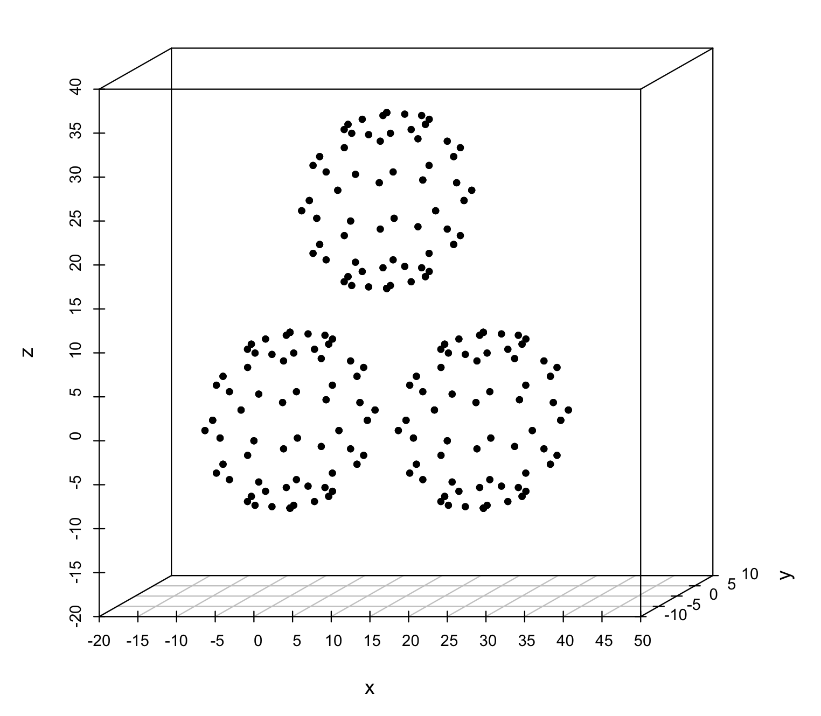The dataset is modeled to include 3 hollow spherical clusters centered at [0,0,0], [25,0,0] and [12.5,0,25] and is visually represented by figure 2. This kind of data distribution represents uniformly distributed distinct clusters which aids the analysis of the behavior of different algorithms in such an environment.

Fig 2 : 3 symmetrically arranged disjoint shells

For this distribution we set the parameters to the following values: δ = 0.05, τ = 1.2, n=3

Table 1

Comparison of the Performance of Clustering Algorithms for synthetic data set in 5.1.1

|  |  |  |
| --- | --- | --- |
| **Algorithm** | **DB Index** | **Computed cluster prototypes** |
| FCM | 3.9148648 | [23.459358, -0.17857742, 0.4919844]  [12.627295, -0.01220799, 24.246544]  [1.7175817, 0.18917465, 0.73784065] |
| RCM | 3.473314 | [12.559172, 0.0, 24.99997]  [25.059166, 0.0, 0.0000066757]  [0.05916691, 0.0, 0.0000066757] |
| RFCM | 3.1817873 | [12.591351, -0.0943699, 26.92252]  [26.12236, 0.049770355, -1.0291548]  [-0.9500904, 0.01245308, -1.0363035] |
| RRFCM | 3.1826534 | [12.584663, 0.0864048, 27.041164]  [26.121044, 0.02057838, -0.9635344]  [-0.9259949,-0.13064575,-1.0205116] |

From the entries in table I, it can be concluded that all the compared algorithms generate similar centroids and perform equally well as per their DB indexes.

### 5.1.2 Three symmetrically overlapping shells

The dataset is modeled to include 3 hollow spherical clusters that partially overlap each other and thereby share data points amongst their clusters. The spheres are centered at [0,0,0], [18,0,0] and [9,0,18]. Figure 3 represents a visual plot of such data points. This kind of data distribution represents uniformly distributed overlapping clusters and is being used as a model to analyze the behavior of different algorithms in such an environment.

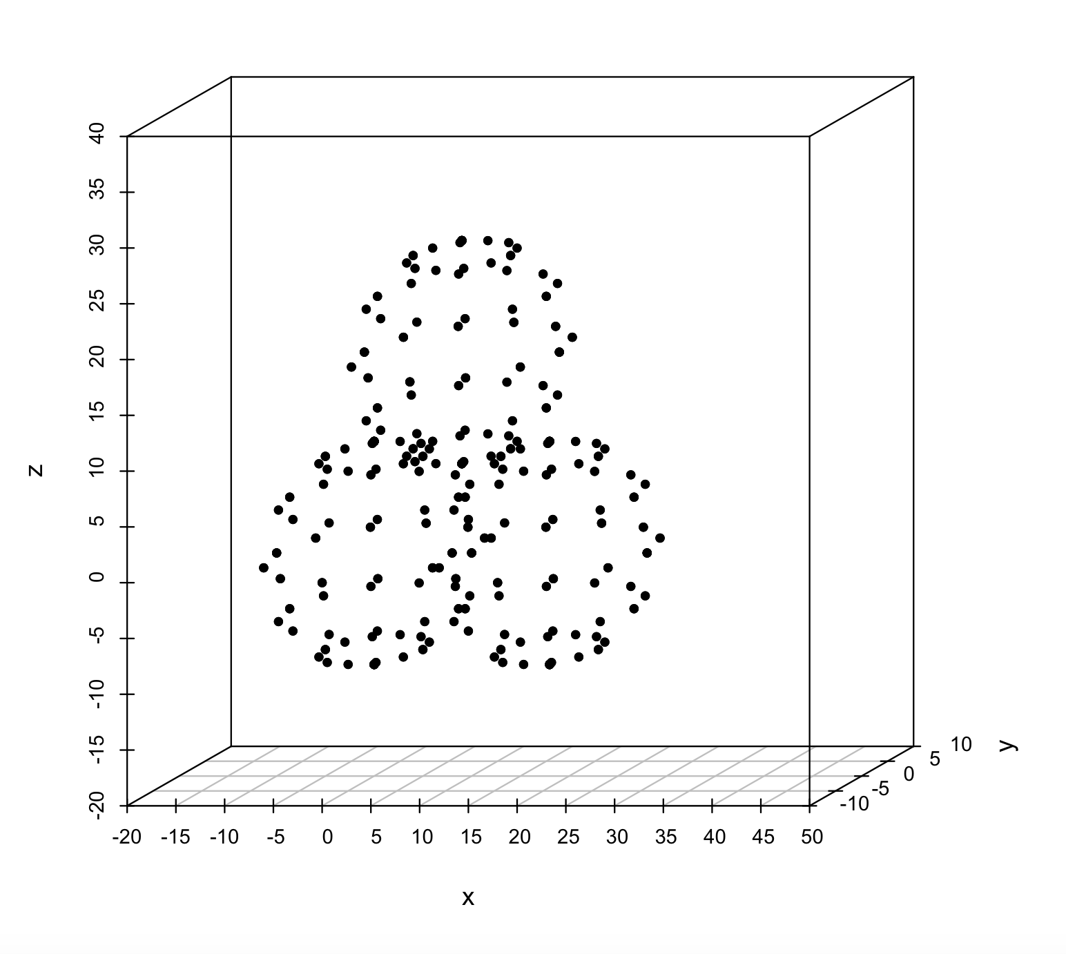

Fig 3 : 3 symmetrically overlapping shells

For this distribution we set the parameters to the following values: δ = 0.05, τ = 1.2, n=3

Table 2

Comparison of the Performance of Clustering Algorithms for synthetic data set in 5.1.2

|  |  |  |
| --- | --- | --- |
| **Algorithm** | **DB Index** | **Computed cluster prototypes** |
| FCM | 6.561525 | [9.860357, -0.24300194, -3.7400084]  [13.460196, -0.8941088, 12.032619]  [4.037366, 1.1050711, 9.261745] |
| RCM | 4.3947577 | [9.074791, -0.06933689, 14.645981]  [18.053236, 0.00797081, -0.6468754]  [0.7432194, 0.025000572, -0.4970808] |
| RFCM | 4.354465 | [9.1782055, -0.43231773, 13.531921]  [17.731144, 0.042783737, -1.9355927]  [0.39754105,0.049051285,-1.8980722] |
| RRFCM | 4.2870336 | [9.936279, 0.011880875, 13.513876]  [18.282022, -0.032226562, -2.133319]  [0.55784225, 0.019529343, -2.249968] |

The lowest DB index value for RRFCM in table II corroborates the efficacy of RRFCM in categorizing the data points when compared to its parent algorithms FCM, RCM, RFCM.

### 5.1.3 Three disjoint spheres with outliers

The dataset is modeled to include 3 hollow spherical clusters centered at [0,0,0], [25,0,0] and [12.5,0,25] and 3 outliers at [500,500,200], [0, -100,500], [480, -200, -20] respectively. Hence the distribution comprises closely positioned spherical clusters and sparsely distributed outliers and is used to simulate an uneven distribution pattern. Figure 4 provides a visual plot of such a distribution.

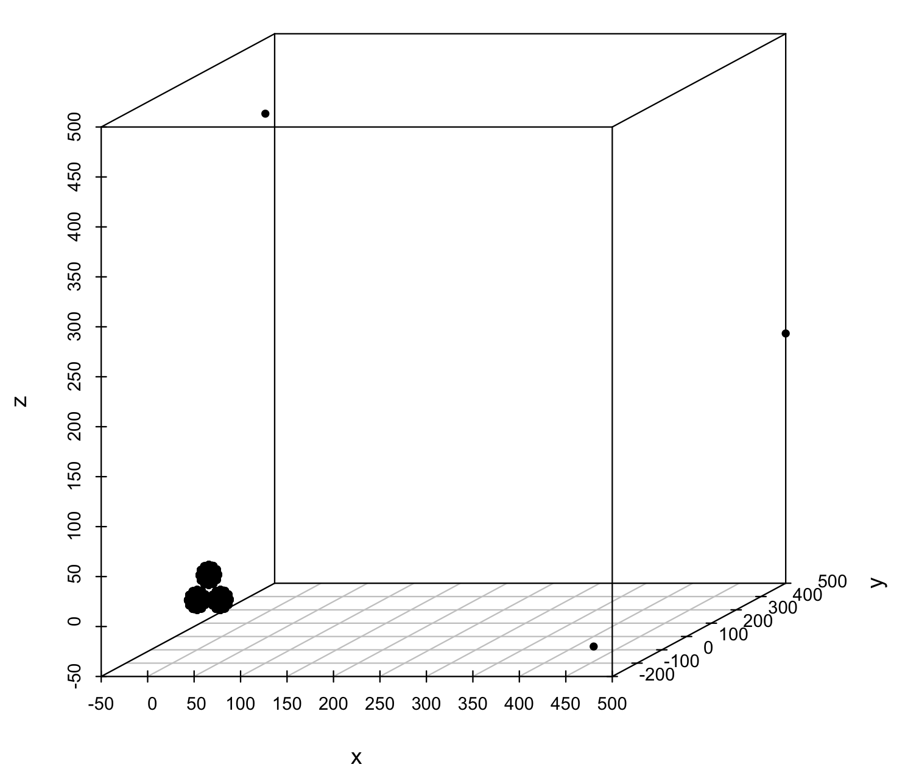

Fig 4 : 3 disjoint symmetrically arranged shells with outliers

For this distribution we set the parameters to the following values: δ = 0.01, τ = 1.1, n=6

Table 3

Comparison of the Performance of Clustering Algorithms for synthetic data set in 5.1.3

|  |  |  |
| --- | --- | --- |
| **Algorithm** | **DB Index** | **Computed cluster prototypes** |
| FCM | 74.461296 | [26.489372, 0.15003967, -6.0380774]  [26.36211, 0.17468262, 7.8214493]  [13.325949, 0.13934326, 32.331154]  [14.191706, 0.19418335, 18.286827]  [1.3584957, 0.14196777, 8.037449]  [0.48079205, 0.1296997, -5.9041824] |
| RCM | 45.571365 | [490.0, 150.0, 90.0]  [100.0, -99.99999, 500.0]  [11.051653, -0.00006104, 23.064278]  [20.32218, -0.00003052, 0.000015259]  [0.698678, -0.000015259, -5.845907]  [-0.82884216, 0.000015259, 6.368858] |
| RFCM | 36.730194 | [500.0, 500.0, 200.0]  [0.0, -99.99999, 500.0]  [13.312202, 0.0004425049, 28.320496]  [26.694458, -0.10858154, -0.97032166]  [-0.46231174, 0.0005951, -6.6621695]  [0.30171585, 0.00027466, 8.60998] |
| RRFCM | 19.42367 | [500.0, 500.0, 200.0]  [100.0, -99.99999, 500.0]  [12.592405, 0.000092, 26.491089]  [480.0, -200.0, -20.0]  [-0.7931824, -0.000137, -0.77895164]  [25.934036, 0.00004578, -0.85129166] |

In table III, the distinctly low DB index for RRFCM when compared to other algorithms is a derivative of the comments mentioned in section III.B.The relative comparison threshold translates to dynamic linear difference threshold for absolute difference which aids isolation of outliers. From the table above it can be observed that only RRFCM accurately isolates the outliers [500.0, 500.0, 200.0], [480.0, -200.0, -20.0], [100.0, -99.99999, 500.0] as separate remote clusters. While RFCM isolates only 2 outliers [500.0, 500.0, 200.0], [100.0, -99.99999, 500.0] it misplaces [480.0, -200.0, -20.0]. RCM and FCM fail to isolate any of the outliers which leads to misplaced centroids and contributes to the poor DB index values.

### 5.1.4 Three overlapping shells with outliers

The dataset is modeled to include 3 hollow spherical clusters with radius 10 that are centered at [0,0,0], [18,0,0] and [9,0,18] and 3 outliers at [500,500,200], [0, -100,500], [480, -200, -20] respectively. Hence the distribution comprises closely packed spherical clusters and sparsely distributed outliers. Figure 5 provides a visual plot of such a distribution.

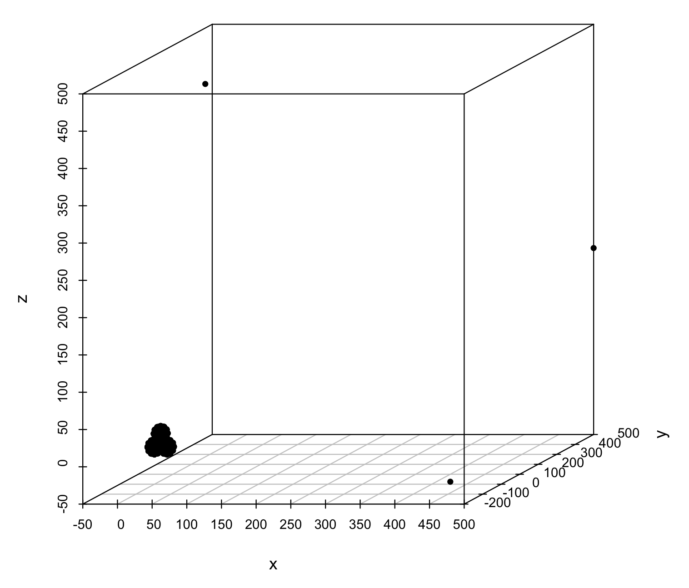

Fig 5 : 3 overlapping shells with outliers

Table 4

Comparison of the Performance of Clustering Algorithms for synthetic data set in 5.1.4

|  |  |  |
| --- | --- | --- |
| **Algorithm** | **DB Index** | **Computed cluster prototypes** |
| FCM | 79.60055 | [18.514194, 0.1737213, -6.747813]  [24.778625, 0.45005798, 4.790283]  [15.203869, 0.13894653, 10.187525]  [9.892382, 0.16438293, 25.806252]  [2.7596283, 0.10935974, 9.557344]  [0.035375595, 0.14904785, -5.58475] |
| RCM | 71.01813 | [14.469616, 0.0000763, 6.5974236]  [360.00003, 66.66666, 226.66666]  [8.549692, -0.00001526, 21.85926]  [19.7827, 0.00003052, -3.026392]  [2.070058, 0.00003052, 10.749918]  [3.7124195, 0.0000763, -3.138937] |
| RFCM | 40.672974 | [500.0, 500.0, 200.0]  [100.0, -99.99999, 500.0]  [21.665413, -0.1903992, -4.568164]  [9.149626, 0.00405884, 24.534378]  [8.173168, 0.0005035, 7.81674]  [-2.314346, 0.00520325, -5.852957] |
| RRFCM | 24.069803 | [500.0, 500.0, 200.0]  [480.0, -200.0, -20.0]  [100.0, -99.99999, 500.0]  [8.995937, 0.00004577, 21.631958]  [19.04202, 0.0000763, -1.2429256]  [-2.012653, -0.000061, -1.7338715] |

Similar to the synthetic data analysis in section 5.1.3 it can be observed from table 5 that only RRFCM isolates the outliers [500.0, 500.0, 200.0], [480.0, -200.0, -20.0], [100.0, -99.99999, 500.0] as separate remote clusters. While RFCM isolates only 2 outliers, RCM and FCM fail to isolate any of the outliers which leads to misplaced centroids and contributes to the poor DB index values. Thus, RRFCM provides more accurate results in case of outliers when compared to other clustering algorithms.

## 5.2 Real Data Set

### 5.2.1 Iris data set

The data set contains 3 classes of 50 instances each, where each class refers to a type of iris plant. Each instance is represented by set of four attributes: sepal length, sepal width, petal length, petal width in cm.

We use this data set to compare the impact of introducing relative strength of membership values as deciding factor for categorizing a data point to the lower approximation in RRFCM as opposed to the absolute linear difference in RFCM. To draw this comparison, we observe the number of data points in the boundary region by varying the threshold values δ and τ in figures 6 and 7. For most data sets, rough fuzzy algorithm gives meaningful results for δ values between 0 to 1, while the refined rough fuzzy algorithm gives meaningful results for τ values between 1 to 2.

Fig 6 : Forest data – trend for total number of objects shared in boundaries of clusters as delta changes for RFCM

In these intervals, the number of objects in the boundary region increases multifold as delta δ increases. As a result, a significant number of objects cannot be categorized definitely to a singe cluster , especially for higher values of δ. In contrast, refined rough fuzzy clustering leaves out very few objects in the boundary (in the order of single digits for values less than 1.5) which leads to well-defined clusters with very few objects shared between these clusters.

Fig 7 : Forest data – trend for total number of objects shared in boundaries of clusters as tao changes for RRFCM

Hence, as theorized, RRFCM produces clusters which have more data points in their lower approximation when compared to clusters generated by the RFCM thereby reducing the degree of uncertainty or vagueness in the membership of the data points in the boundaries of these clusters.

**5. Conclusion**

This paper is geared to analyze shortcomings of different phases involved in rough fuzzy clustering algorithm and proposes alternative approaches for each of these tasks in order to develop more accurate partitions of a data set than its parent rough, fuzzy or hybrid rough fuzzy algorithms. The proposed refinements address two issues: hollow identical clusters generated by rough clustering algorithms

and the incorrect categorization of data to clusters based on absolute linear difference in certain data distributions. The paper identifies the causes for these two issues and devises alternatives based on these findings.

With the two solutions proposed, we formulate and apply the new algorithm to different types of data sets – synthetic and real dataset. Using DB index as the objective basis of evaluating different clustering algorithm, the refined rough clustering algorithm emerges as the most efficient method for partitioning symmetric distributions and distributions with outliers. Specifically, in the case of outliers or noise, RFCM gave noticeably accurate results by isolating the outliers into separate clusters while the other algorithms fail to isolate them resulting in d. Hence, these refinements are significantly helpful in clustering noisy data. Moreover, from the comparative study of RFCM and RRFCM on their application to real data sets, it is evident that RRFCM categorizes more data points to the lower approximations of clusters thereby lowering the degree of uncertainty and vagueness associated with boundaries of clusters.

**Acknowledgement**

We are grateful to Vellore Institute of Technology, India for providing us an excellent and co-operative research environment while conducting this research there.

**References**

[1] H.J. Zimmermann, Fuzzy Set Theory and its Applications, fourth ed., Kluwer Academic Publishers, Boston, 2001

[2] Z. Pawlak, Rough sets, Int. J. Inform. Comput. Sci. 11 (1982) 145–172.

[3] Duda, R. O., Hart, P. E., Stork, D. G.: Pattern Classification and Scene Analysis , John Wiley & Sons, New

York, 1999.

[4] Jain, A. K., Dubes, R. C.: Algorithms for Clustering Data , Englewood Cliffs, N.J.: Prentice Hall, 1988.

[5] Jain, A. K., Murty, M. N., Flynn, P. J.: Data Clustering: A Review, ACM Computing Surveys , 31 (3), 1999,

264–323.

[6] McQueen, J.: SomeMethods for Classification and Analysis of Multivariate Observations, Proc. Fifth Berkeley

Symp. Math. Statistics and Probability , 1967, 281–297.

[7] James C. Bezdek, Robert Ehrlich, William Full: FCM: The Fuzzy C-Means Clustering Algorithm, Computers & Geosciences Vol. 10, No. 2-3, pp. 191-203, 1984.

[8] Krishnapuram, R., Keller, J. M.: A Possibilistic Approach to Clustering, IEEE Transactions on Fuzzy Systems ,

1 (2), 1993, 98–110

[9] Krishnapuram, R., Keller, J. M.: The Possibilistic C-Means Algorithm: Insights and Recommendations,

IEEE Transactions on Fuzzy Systems , 4 (3), 1996, 385–393.

[10] Barni, M., Cappellini, V., Mecocci, A.: Comments on A Possibilistic Approach to Clustering, IEEE Transactions

on Fuzzy Systems , 4 (3), 1996, 393–396

[11] Lingras P, Peters G (2012) Applying rough set concepts to clustering. Rough Sets: selected methods and applications in management and engineering. Springer, London, pp 23–38

[12] H.A. do Prado, P.M. Engel, H.C. Filho, Rough clustering: an alternative to find meaningful clusters by using the reducts from a dataset, in: Rough Sets and Current Trends in Computing: Third International Conference, RSCTC 2002, Lecture Notes in Computer Science, vol. 2475, Springer, Berlin, 2002, pp. 234–238.

[13] K.E. Voges, N.K. Pope, M.R. Brown, Heuristics and Optimization for Knowledge Discovery, in: Cluster Analysis of Marketing Data Examining On-Line Shopping Orientation:A Comparison of k-Means and Rough Clustering Approaches, Idea Group Publishing, Hershey,

PA, 2002, pp. 207–224.

[14] Maji, P. and Pal, S.K.: RFCM: A Hybrid Clustering Algorithm using rough and fuzzy set, Fundamenta Informaticae 80.4 (2007): 475-496.

[15] Z. Pawlak, Rough Sets, Theoretical Aspects of Reasoning About Data. Dordrecht, The Netherlands: Kluwer, 1991

[16] Wang XY, Garibaldi JM. A comparison of fuzzy and non-fuzzy clustering techniques in cancer diagnosis; 2005

[17] Liu, T.; Rosenberg, C. R. & Rowley, H. A. (2007), Clustering Billions of Images with Large Scale Nearest Neighbor Search., *in* 'WACV' , IEEE Computer Society, , pp. 28.

[18] W. W. Hargrove and F. M. Hoffman. Using Multivariate Clustering to Characterize Ecoregion Borders. Comput. Sci. Eng., 1(4):18–25, 1999

[19] D. L. Davies and D. W. Bouldin: Cluster Separation Measure, IEEE Transactions on Pattern Analysis and Machine Intelligence, Vol. 1, No. 2, pp. 95-104, 1979

[20] George Peters: Some refinements in rough k-means clustering, Elsevier, Pattern recognition 39 (2006) 1481-1491.

1.